**The Holocaust Documentation and Education Center, Inc.,   
presents**

**Daniel Levin, featured guest author**

**&**

**Winner of the 2022 Independent Publishers’ Book Award Gold for History for  
Violins and Hope | From the Holocaust to Symphony Hall**

**Date: Sunday, February 4, 2024**

**Time: 1:30 – 3:30 PM  
Location: Holocaust Documentation and Education Center, Inc.  
303 N. Federal Hwy, Dania Beach, FL 33009**

**- Free Admission -**

**Please note, for Security Purposes, all guests must RSVP!  
To RSVP, please contact Jeanine at 954-929-5690 EXT. 314 or email AssistCoordinator@hdec.org**

 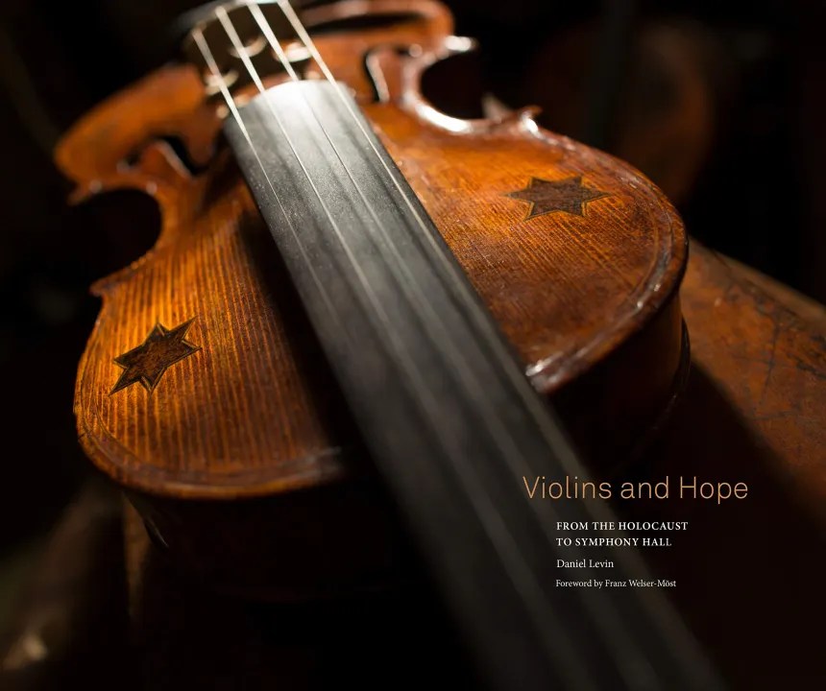

**Daniel Levin is an author, contemporary artist, documentarian, filmmaker, and professor, whose works primarily address societal concerns. He holds an MFA in Visual Art from the Vermont College of Fine Art, and a BFA in Documentary Photography from the Rochester Institute of Technology, where he was awarded the Institute’s prestigious Purchase Prize.**

**His book Violins and Hope | From the Holocaust to Symphony Hall was the winner of the 2022 Independent Publishers’ Book Award Gold for History - coffee table scale, as well as a Finalist for the IPPY National Book of the Year Award for Photography in 2021.**

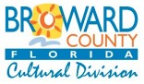

**Sponsored locally by: Major Support for the Holocaust Documentation & Education Center, Inc. is provided by the Broward County Cultural Division, the Cultural Council, and the Broward County Board of Commissioners, JM Family Enterprises, Inc., Susie Edelsburg, Steven & Nora Weiss, Florida Peninsular Insurance Company, Senator Nan & David Rich, and Irving and Evelyn Philanthropic Fund – Lawrence Denmark and Yuki Denmark.**