**You are cordially invited to Attend the GRAND OPENING of the   
Holocaust Documentation & Education Center’s**

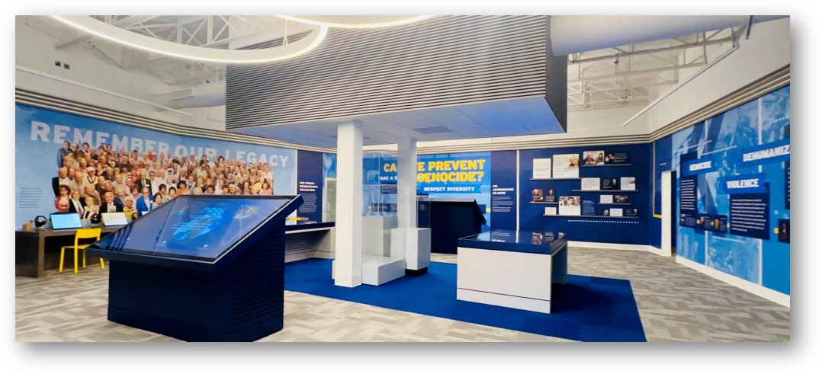**Interactive Learning Center**

**Interactive Learning Center photo courtesy of Howard Sonnenschein**

**SUNDAY, OCTOBER 15, 2023, FROM 2:30 – 4:30 PM**

**We wish to announce the opening of our Interactive Learning Center. This is one of the first in the country and will feature Interactive Smart Tables known as “intelligence furniture”. These Smart Tables will include artifacts, documents, and memorabilia of the Holocaust Documentation & Education Center’s Archival Collection, six oral history stations to enable the visitor to access the USC Shoah Foundation’s 55,000+ Oral Histories, and the Holocaust Documentation & Education Center’s Oral Histories.**

**The Interactive Learning Center will also feature two mini theatres to showcase the USC Shoah Foundation’s produced Dimensions in Testimony (DiTs) of Holocaust Survivors. This trailblazing technology will allow visitors to have the unique opportunity to engage and question Stella Sonnenschein & Morris Dan, two of South Florida’s Holocaust Survivors for years to come and a 5,000 Volume Holocaust Library.**

**303 N. Federal Highway, Dania Beach, FL 33004**

**General Admission $10 | Student Admission $5**

**Survivors, Liberators, Spouses & Service Members - Free Admission**

**To Attend, Please RSVP to 954-929-5690 EXT: 314 or AssistCoordinator@hdec.org**

**The Interactive Learning Center was made possible by the following:**

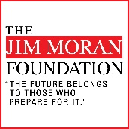

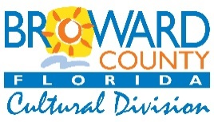

**The State of Florida, Department of State. Division of Cultural Affairs and Florida Council on Arts and Culture, The Jim Moran Foundation, Broward County Commissioners as recommended by the Broward County Cultural Council, & The Scherr Family Foundation.**