Erick Canelon-2022 Contest Entry-Description of Artwork

12th Grade

786-328-0653

[erickcanelon@gmail.com](mailto:erickcanelon@gmail.com)

Charles W. Flanagan High School

12800 Taft St, Pembroke Pines, FL 33028  
  
Mr.Brian Lynn  
  
[brian.lynn@browardschools.com](mailto:brian.lynn@browardschools.com) 

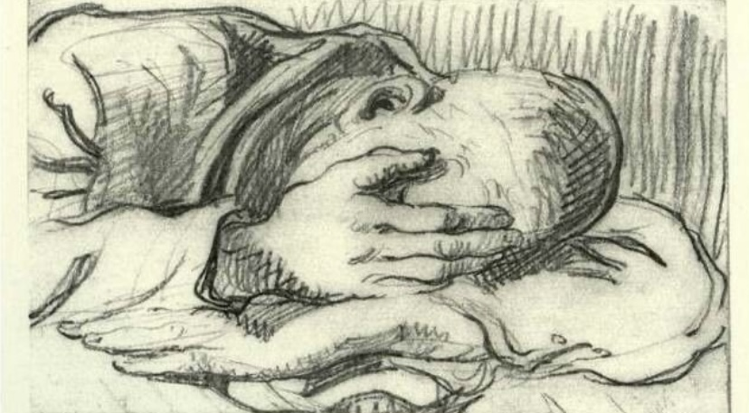

This is a drawing of a fellow Jew in frustration, hiding and he’s covering his face to not see what is going on in front of him since German’s are looking for people around where he is hiding.

The description title on it would be: “Hiding in fear”

And I think the most important lesson about the Holocaust is that it shows us how terrible it can be when an institution is fragile and human rights are not protected and get thrown away, it shows us what happens when someone with horrible strong beliefs gets power as well.